**Human diagnosis project (Human Dx)**



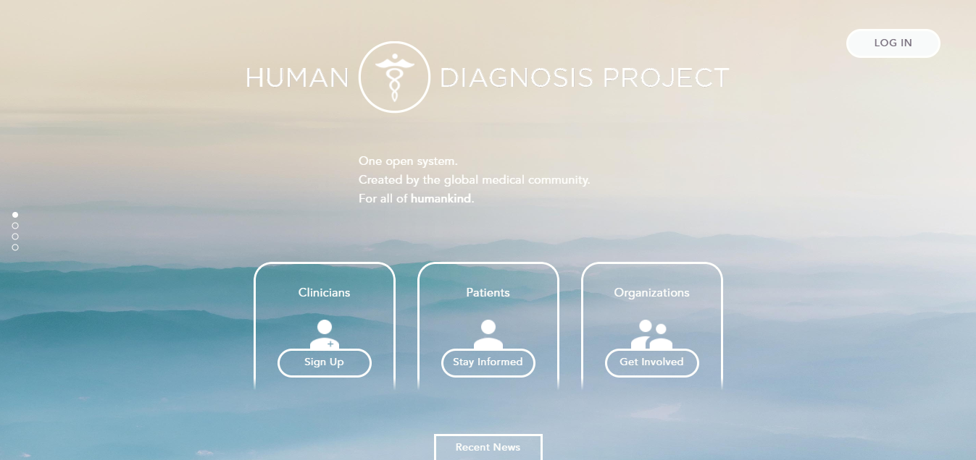

<https://www.humandx.org/>

**Country:** USA (created in 2017)

**Stakeholders:** Clinicians – Patients - Organizations

**Main features:**

1. **Diagnose patients**
2. **Train doctors:** A doctor can create a case study. Case studies are mailed to doctors every day. After a doctor solves the case study he can see solutions of other doctors, and the system measures his accuracy according to what it learnt from previous experience and the other solutions

**Pros:**

1. The system improves itself with the help of machine learning
2. Helps both the machine (through machine learning) and the human (through case studies)
3. Case studies are reviewed before being published

**Cons:**

1. Depends totally on the volunteer of doctors who create or solve the case studies
2. Does not verify that you are a doctor while you sign up

**Note:** The system is not fully developed yet

***

**Vezeeta (Book the Best Doctor in two minutes)**



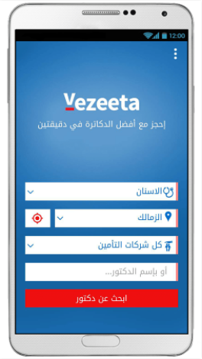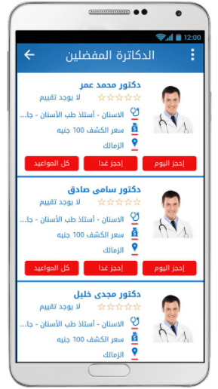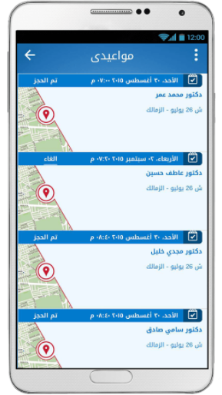

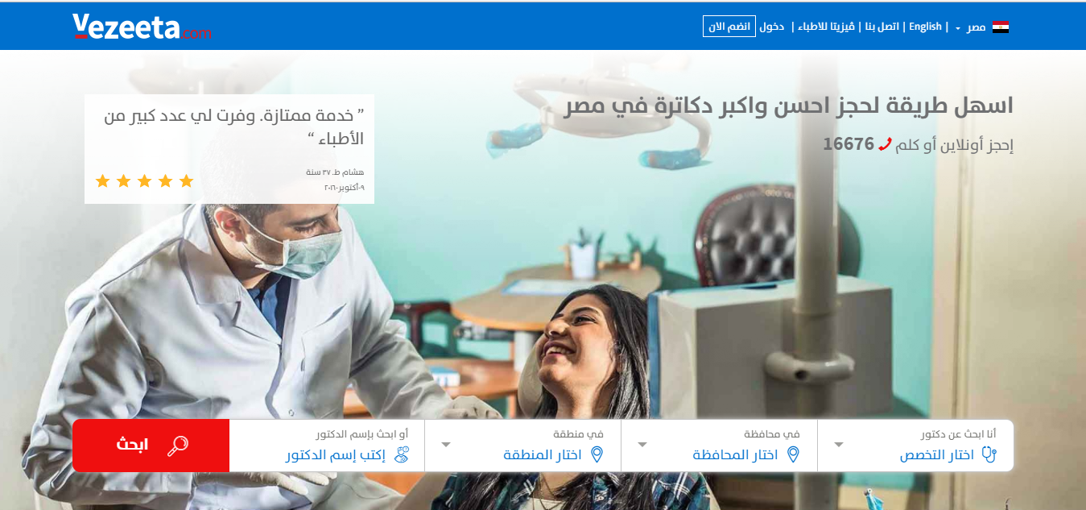

<https://www.vezeeta.com/>

**Country:** Egypt

**Stakeholders:** Patient – Doctors

**Main features:**

1. Search for doctors by region, specialty or name
2. Reserve an appointment with the chosen doctor
3. Save a favorite list of doctors
4. Give a rating to doctors

**Technologies:** Android - Web

**Cons:**

1. Covers only regions in Cairo and few others around it
2. Some functions are separated in different vezeeta apps despite being related. For example, a doctor needs to install “Vezeeta Profile” just to publish his profile to patients, while he needs to install “Vezeeta Care” to add data of his patients or see their lab/radiation results

***

**Roshetta**



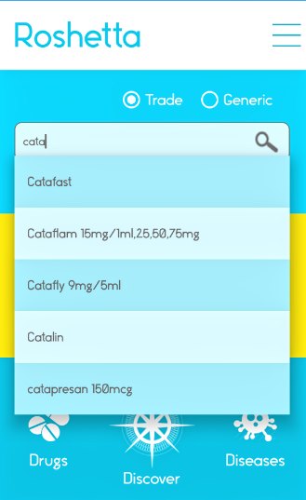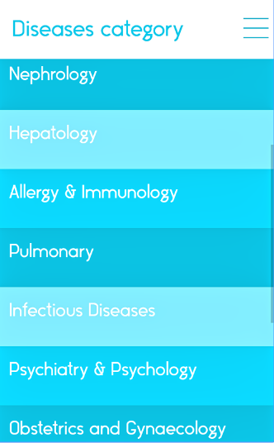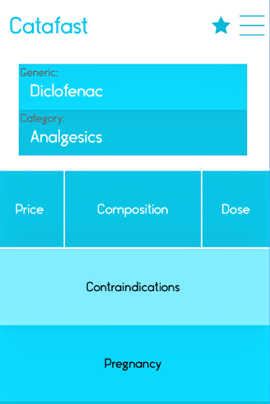

**Country:** Egypt - Cairo

**Stakeholders:** pharmacists – doctors

**Main features:**

1. App gives updated price, composition and Dose of the searched drug
2. Give the alternative of the drug
3. User has favorite to add drugs, diseases
4. App contains diseases and its information such that (treatment – diagnosis and symptoms)

**Technology:** Android

**Cons:**

1. App doesn’t support Arabic languages
2. There is no image for drugs
3. App doesn’t give the name of the drugs which conflict with chosen drug

**عالج نفسك بدون طبيب**



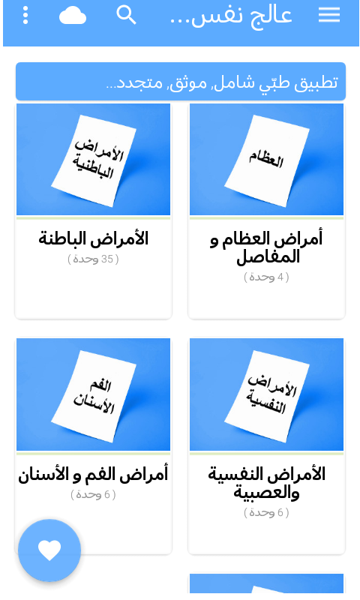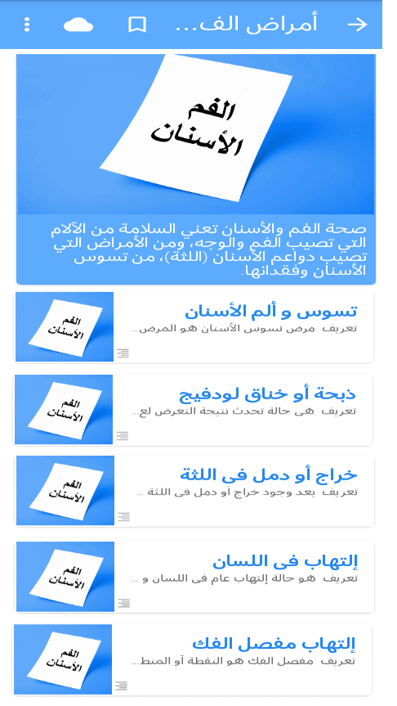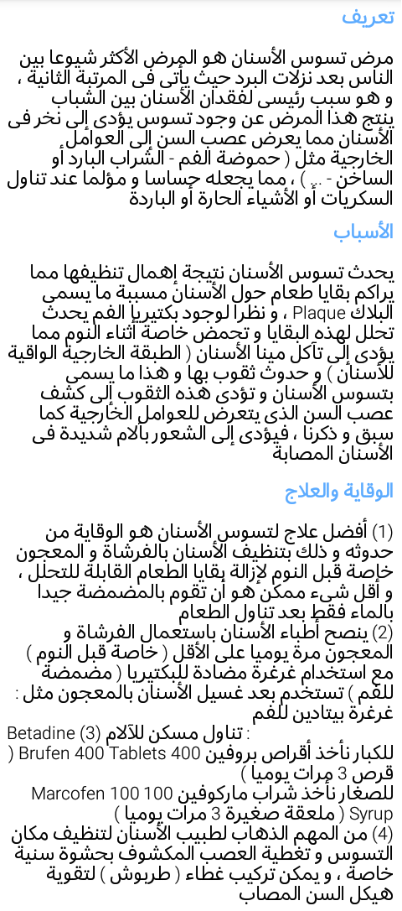

**Stakeholders:** patient

**Main features:**

1. App contains many diseases which classified by category
2. Contains definition of disease, causes and treatments

**Technology:** Android

**Cons:** recommends chemical drugs, this can be harmful

**\*\*\***

**Book My Doctor (Online Doctor Appointment Booking System)**



**Country:** USA

**Stakeholders:** patient – doctor

**Patient Features:**

1. Can choose and book an appointment at the flexible time and date.
2. Can search for doctor according to specialty and location.
3. Can write review about the doctor and can select doctors according to another user feedback.
4. Can access all previous check-in details and medical past appointments.
5. Notify patient with appointments
6. Know how many patients reserve an appointment with doctor

**Doctor features:**

1. View Appointments
2. Manage appointments
3. Can updates edit profiles and can add images
4. Can schedule their availability dates and the day they are on vacation

**Cons:** There are no medicines or prescriptions in the patient’s history.

***

**MyChart**



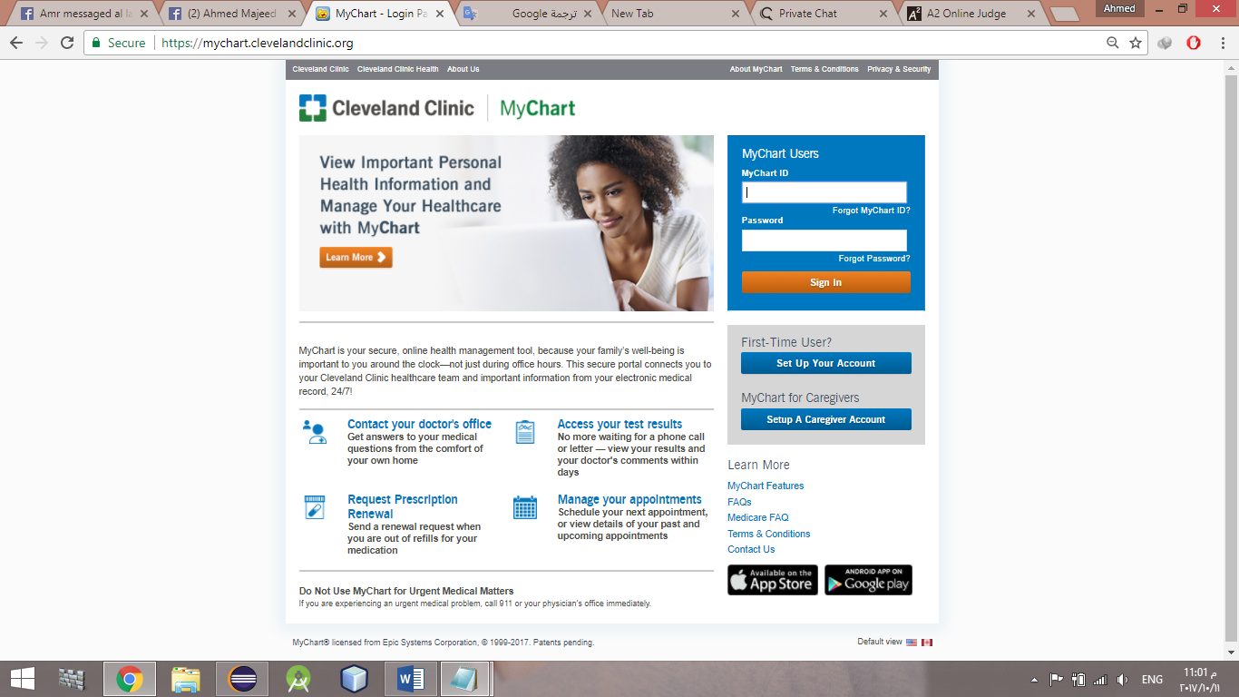

**Country:** USA

**Main features:**

1. allows patient to access his/her medical records on his/her phone at any time ( patient can quickly see which vaccinations he/she has had and when at a glance, along with the last time he/she visited the doctor and which prescriptions he/she is taking.
2. patient can even send a non-urgent message to his/her clinic and receive a response within a couple days.

**Technologies:** Android and IOS

**Pros:** patient can see all his/her information online if you can’t access it due to cellular outages.

***

**My Dawaai**



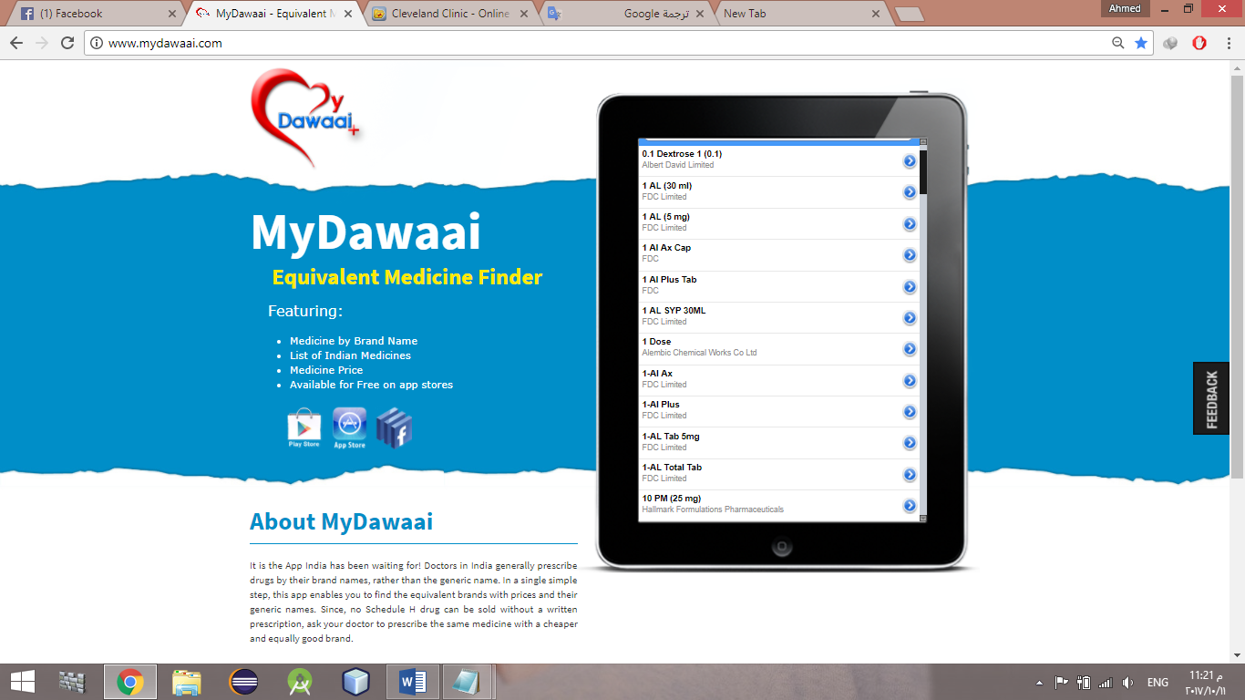

**Country:** India

**Main features:**

1. App will help you quickly find equivalent brands of medicines along with their prices and generic names.

**Technologies:** Android and IOS

**Pros:** Unlike other drug search engines, My Dawaai’s database also includes details of small drug manufacturers in India.

**Cons:** App only contains list of Indian medicines.

***

**Doctor on Demand**

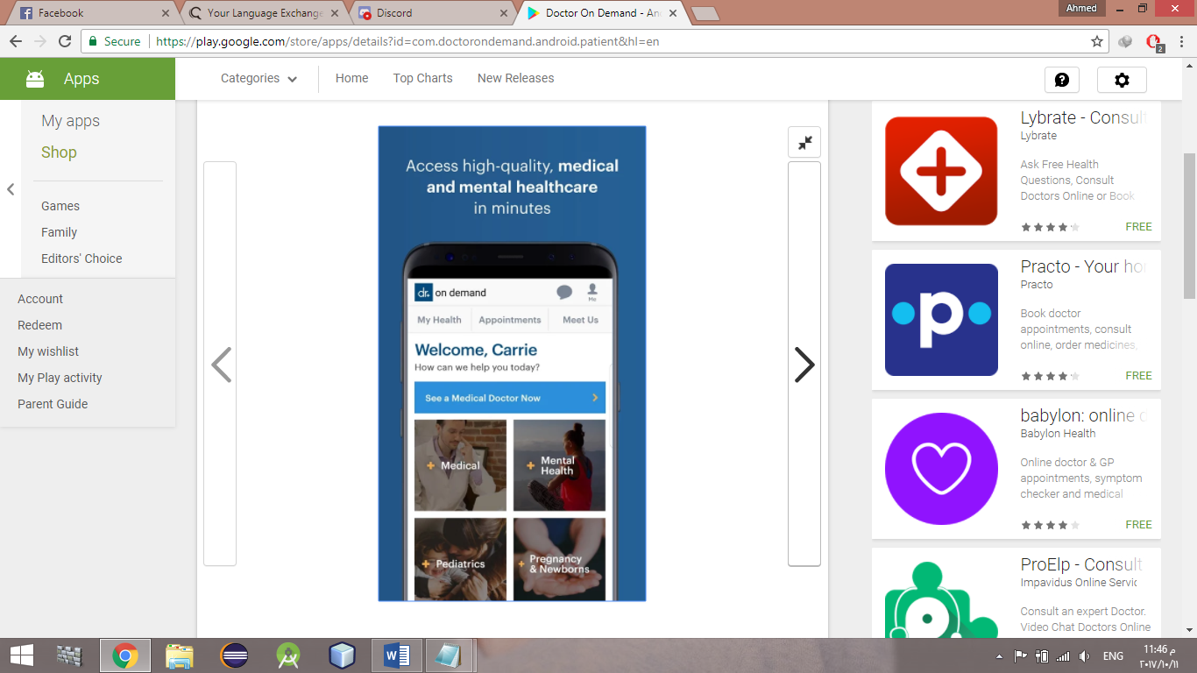



**Main features:**

1. app lets you instantly connect with licensed professionals via video chats and audio calls.

**Technologies:** Android and IOS

**Cons:**

1. A 15-minute will cost you $40.
2. Patient isn’t able to choose his/her doctor.

**Micromedex**

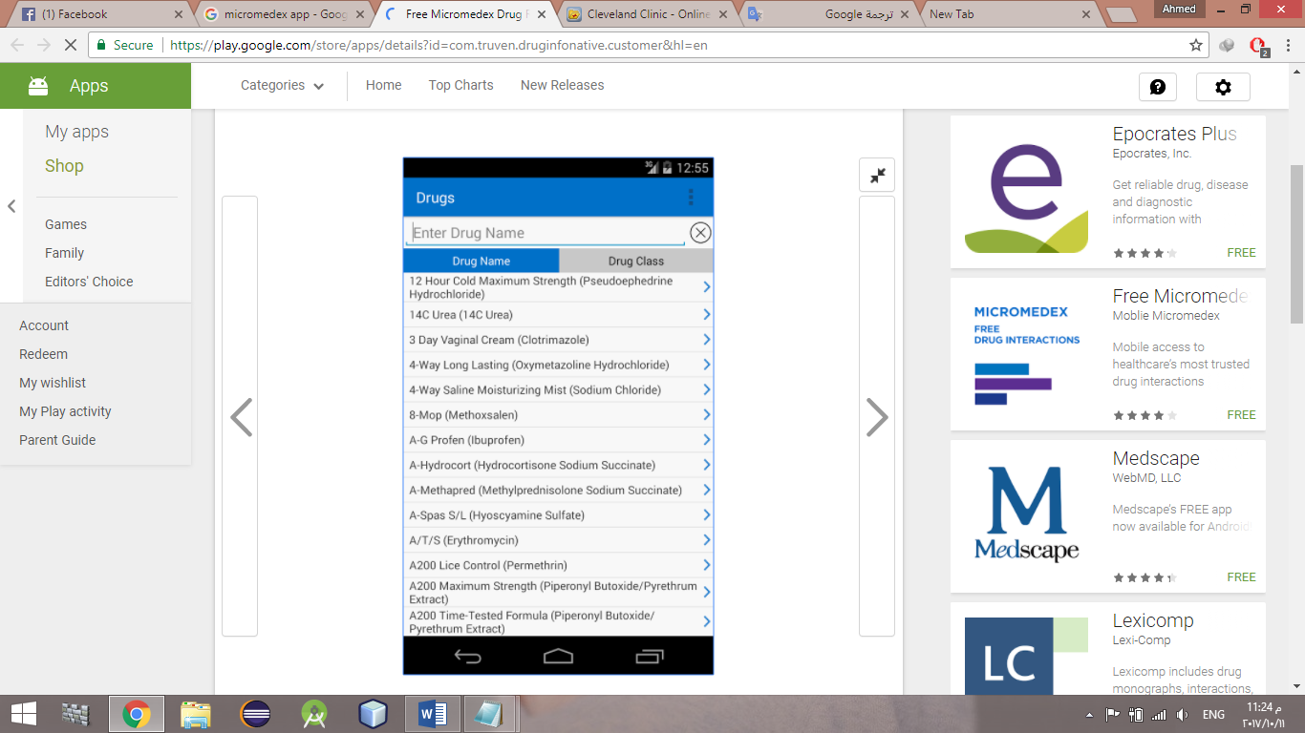

**Main features:**

1. App support patient with proper drug dosage and medicine recommendations.
2. Patient can search the name of a specific drug to find out how it should be taken, as well as any potential side effects.
3. Patient can also search by ailment for drug recommendations that will combat his/her medical problem.

**Technology:** Android

**Pros:**

1. Updated monthly.
2. Ability to use without a WiFi or cellular connection.

**Cons:** Use for $3 a year.

***